**Phase – 4 Machine Learning Model Creation & deployment in IBM Watson Studio**

|  |  |
| --- | --- |
| **Team ID** | **671** |
| **Project Name** | **Machine Learning Model Deployment using IBM Cloud Watson Studio** |

**Model Creation**

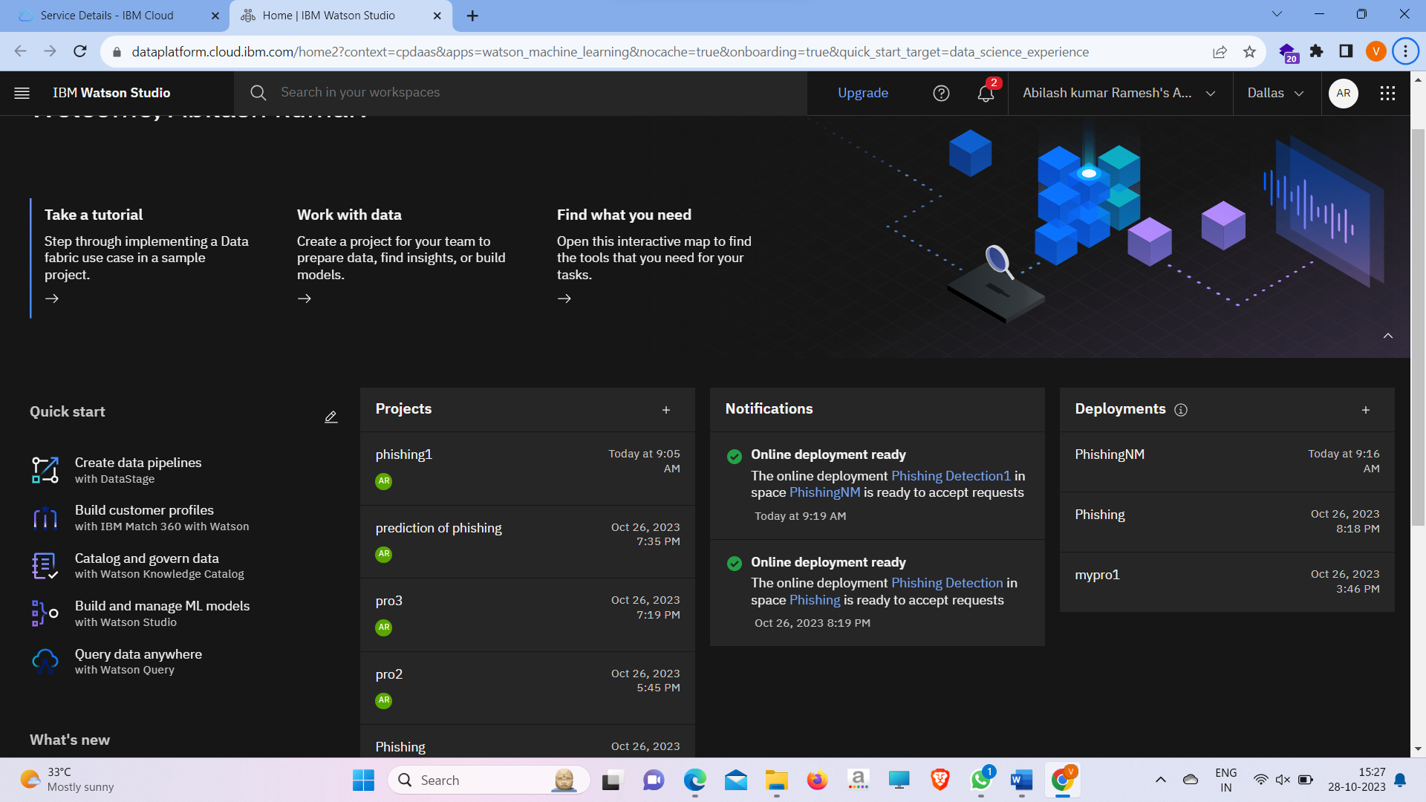

**Dataset**

**Train the Model**

**Algorithm Choosing**

**Model Created Successfully**

**Deployment as webservice**

**Test the Model**

**API REFERENCE**

**By using API Accessing the Model**

